THE IMPACT OF AI ON STUDENTS
MINI PROJECT REPORT

INTRODUCTION
Artificial Intelligence (AI), particularly Generative AI (GenAI), has become an increasingly important part of modern education. Students use AI-powered tools to assist with learning, research, writing, coding, problem-solving, and other academic activities. While these technologies have the potential to enhance learning efficiency and productivity, they have also raised concerns regarding academic integrity, overdependence, critical thinking, and student wellbeing.
Understanding how AI influences students' academic performance and learning behaviours is becoming increasingly important for both educational institutions and policymakers. Data analytics provides an effective way to identify patterns in AI usage and evaluate its relationship with academic achievement, study habits, and wellbeing.
This mini project analyses the AI Impact on Students dataset using Microsoft Excel and Microsoft Power BI. Microsoft Excel was used to clean, prepare, and transform the dataset before creating an exploratory dashboard. Microsoft Power BI was then used to develop an interactive business intelligence report that provides deeper insights into the relationship between AI usage and student outcomes.

AIM
The aim of this project is to analyse the impact of Generative Artificial Intelligence on students' academic performance, study habits and wellbeing using Microsoft Excel and Microsoft Power BI.

OBJECTIVES
The objectives of this project are to:
- Prepare and clean the dataset to ensure data quality and consistency.
- Perform exploratory data analysis using Microsoft Excel.
- Develop interactive dashboards using Microsoft Power BI.
- Analyse the relationship between AI usage and academic performance.
- Examine the impact of AI usage on student behaviour and wellbeing.
- Present findings through meaningful visualisations and data-driven insights.

SOFTWARES USED
Two Microsoft applications were used throughout the project.
Microsoft Excel
Microsoft Excel was used for:
- Data cleaning
- Missing value treatment
- Data transformation
- Exploratory data analysis
- Development of the initial dashboard
Microsoft Power BI
Microsoft Power BI was used for:
- Data modelling
- Creating DAX measures
- Interactive dashboard development
- Data visualisation
- Business intelligence reporting
The combination of Excel and Power BI provided a complete workflow, beginning with data preparation and ending with interactive analysis and visualisation.

DATASET OVERVIEW AND DATA PREPARATION
Dataset Overview
The dataset used for this project was obtained from Kaggle and contains 50,000 student records across 16 variables. The dataset explores various aspects of students' academic performance, AI usage, learning behaviour, and wellbeing, making it suitable for analysing the impact of Generative AI in education.
The dataset includes variables such as:
- Student ID
- Major Category
- Year of Study
- Pre Semester GPA
- Post Semester GPA
- Weekly GenAI Hours
- Prompt Engineering Skill
- Skill Retention Score
- Traditional Study Hours
- Perceived AI Dependency
- Anxiety Level During Exams
- Burnout Risk Level
- Tool Diversity
- Institutional Policy
- Paid Subscription
- Primary Use Case
The diversity of variables enables the analysis of both academic outcomes and behavioural trends associated with AI usage.

Data Cleaning
Before conducting the analysis, the dataset was carefully examined to identify missing values, duplicate records, and inconsistencies that could affect the accuracy of the results.
Missing values were identified using Excel's COUNTBLANK() function together with filtering techniques. A total of 27 missing values were identified across four variables.
Variable | Missing Values | Treatment Method
Major Category | 3 | Mode
Pre Semester GPA | 10 | Mean
Weekly GenAI Hours | 10 | Median
Skill Retention Score | 4 | Mean

Different imputation techniques were selected according to the nature of each variable.
- Since Major Category is a categorical variable, the missing values were replaced using the mode, with STEM being the most frequently occurring category.
- For Pre Semester GPA and Skill Retention Score, missing values were replaced using the mean, as both variables were continuous and approximately normally distributed.
- For Weekly GenAI Hours, the median was selected because the variable contained a wider range of values, making it less sensitive to potential outliers than the mean.
Following the treatment of missing values, duplicate records were checked and no duplicate Student IDs were identified. The Paid Subscription field was also standardised by converting TRUE/FALSE values into Yes/No to improve readability within the dashboards.
These cleaning steps ensured that the dataset was complete, accurate, and suitable for further analysis.

Data Transformation
To support the analysis, two additional calculated columns were created in Microsoft Excel.
- GPA Change
A new column named GPA Change was created to measure the difference between students' academic performance before and after the semester. This variable was used extensively throughout the dashboards to evaluate changes in academic performance.

- AI Usage Group
Students were categorised according to their weekly AI usage to simplify comparisons between different levels of AI adoption.
Weekly GenAI Hours | AI Usage Group
0 – 5 Hours | Low
6 – 15 Hours | Moderate
Above 15 Hours | High

This threshold was chosen to reflect the natural distribution of the data around the dataset mean of 8.43 hours per week, while also representing meaningfully distinct usage patterns: occasional use (Low), regular integrated use (Moderate), and intensive daily reliance (High). Grouping AI usage in this way enabled clearer comparison of academic and wellbeing outcomes across different levels of AI adoption throughout the analysis.

Formulas, Functions and Measures Used

FUNCTION/FORMULA | PURPOSE
COUNTBLANK() | Counted the number of missing values in each column to identify incomplete records.
COUNTIF() | Counted the frequency of categorical values to identify the mode for the Major Category variable before replacing missing values.
IF() | Created the AI Usage Group calculated column by classifying students into Low, Moderate, and High AI usage groups.
IF(ISBLANK()) | Checked for blank cells and replaced missing values using the appropriate statistical measure (mean, median, or mode).
AVERAGE() | Calculated the average values for GPA Change, Weekly AI Hours, and Skill Retention Score used in the KPI cards on the Excel dashboard.
Post Semester GPA – Pre Semester GPA | Calculated the GPA Change for each student.

MICROSOFT EXCEL DASHBOARD
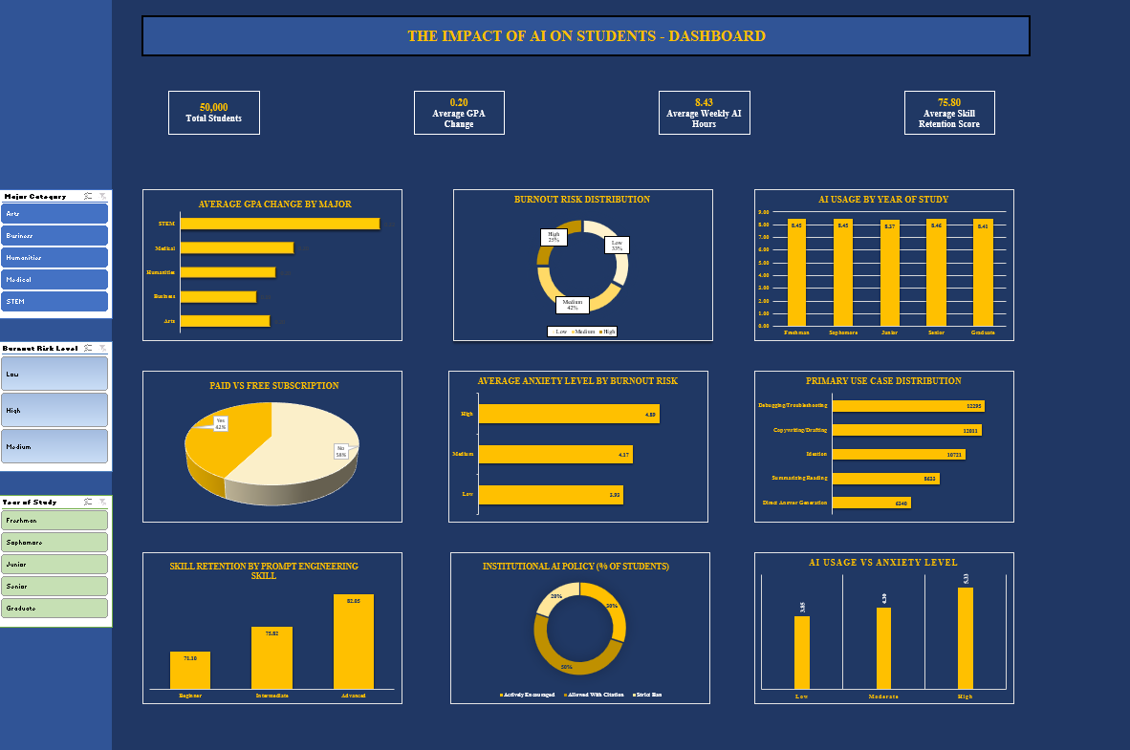
Dashboard Overview
Following the completion of data cleaning and transformation, an interactive dashboard was developed in Microsoft Excel to perform exploratory data analysis and present a high-level overview of the dataset. The dashboard combines Key Performance Indicator (KPI) cards, charts and slicers to summarise the relationship between AI usage, academic performance, student wellbeing and institutional policies.
The dashboard includes four KPI cards displaying the total number of students, average GPA change, average weekly AI usage, and average skill retention score. Interactive slicers for Major Category, Burnout Risk Level, and Year of Study enable users to filter the visualisations dynamically and explore trends across different student groups.
The dashboard consists of Bar charts, Column charts, Pie chart, Donut charts and KPI cards, providing an accessible overview of the dataset before conducting more detailed analysis in Microsoft Power BI.
MICROSOFT POWER BI REPORT
Following the exploratory analysis in Microsoft Excel, the cleaned dataset was imported into Microsoft Power BI to develop a comprehensive and interactive business intelligence report. After importing the dataset, it was opened in Power Query Editor to verify that all variables had the correct data types. Numerical fields were formatted appropriately, and decimal places were standardised to two decimal places to ensure consistency and improve the readability of calculations and visualisations.
Once the data preparation was completed, the dataset was loaded into Power BI, where DAX measures were created and interactive dashboards were developed. Unlike the Excel dashboard, which provides an overall summary of the data, the Power BI report examines specific aspects of AI usage through dedicated report pages, allowing users to explore academic performance, student behaviour, wellbeing, and institutional policies in greater depth.
The report consists of four interactive pages:
- Executive Dashboard
- Academic Performance
- Student Behaviour and Wellbeing
- Institutional Insights

Power BI Features and DAX Measures
To enhance the analytical capabilities of the report, several Power BI features were implemented, including KPI cards, slicers, navigation buttons, interactive charts, matrices, and DAX measures.
A total of nine DAX measures were created to calculate key performance indicators used throughout the report.
- Total Students
- Average GPA Change
- Average Weekly AI Hours
- Average Skill Retention Score
- Average Anxiety Level
- Average AI Dependency
- Average Traditional Study Hours
- Average Pre Semester GPA
- Average Post Semester GPA

DASHBOARD
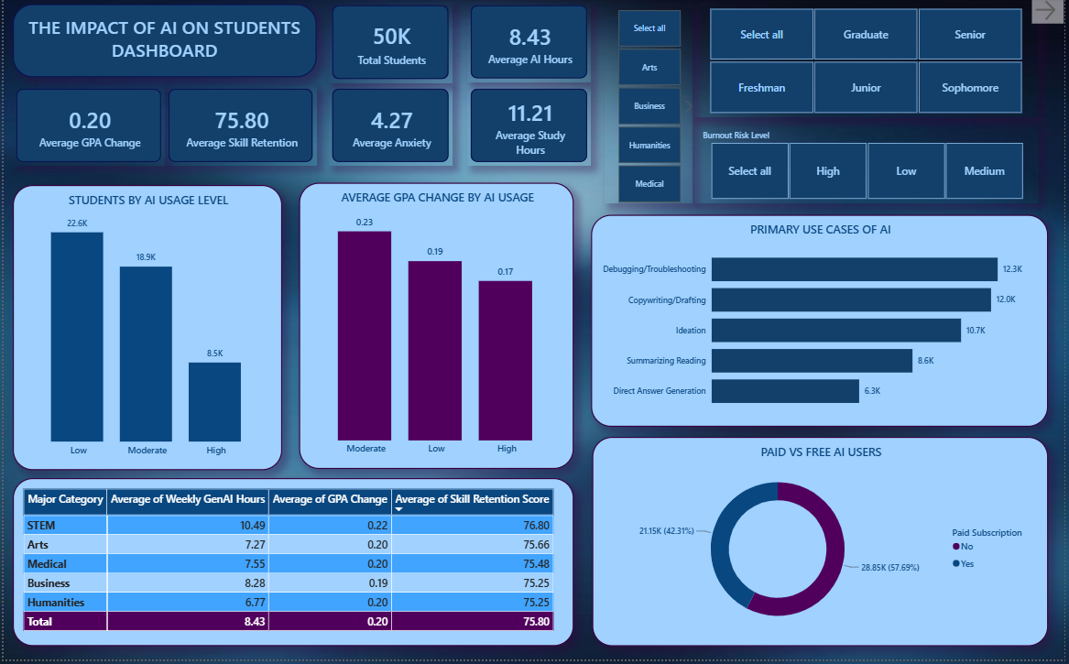
The Dashboard provides a high-level overview of the dataset using KPI cards, Clustered column charts, a Bar chart, a Donut chart and a matrix. These visualisations summarise key metrics related to AI usage, academic performance, subscription types, and primary AI use cases.
Key Insights
- Moderate AI users recorded the highest average GPA improvement.
- Most students used free AI tools rather than paid subscriptions.
- The dashboard provides an overview of students' primary AI use cases and AI usage groups.
- Summary statistics provide a quick understanding of overall academic performance and AI usage across the dataset.

ACADEMIC PERFORMANCE
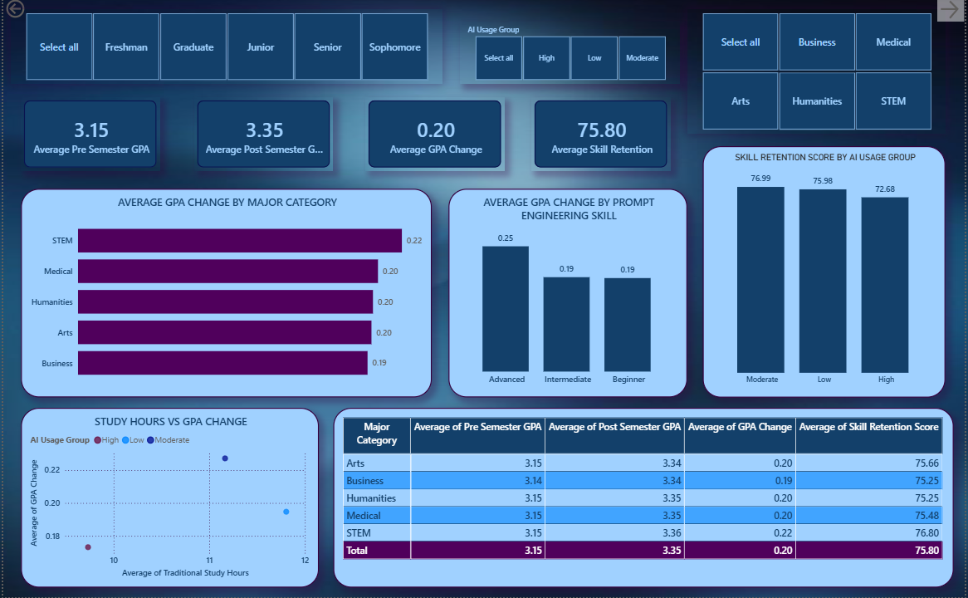
This page analyses the relationship between AI usage and students' academic outcomes using Clustered bar chart, Clustered column charts, a Scatter chart, KPI cards and a matrix. These visualisations compare GPA improvement, prompt engineering skills, skill retention, and traditional study habits across different student groups.
Key Insights
- Students with moderate AI usage achieved the highest average GPA improvement.
- Advanced prompt engineering skills were associated with stronger academic performance.
- Moderate AI users recorded higher average skill retention than high AI users.
- Students who continued traditional study practices alongside AI generally achieved more favourable academic outcomes.

STUDENT BEHAVIOUR AND WELL-BEING
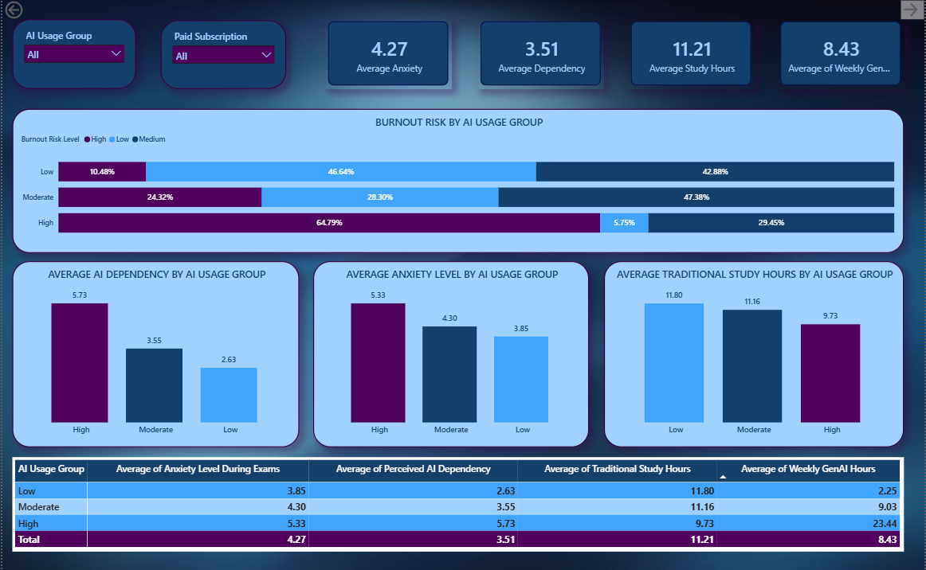
This page examines the impact of AI usage on student wellbeing using 100% Stacked column chart, Clustered column charts, KPI cards and a matrix. The visualisations explore patterns in burnout risk, AI dependency, anxiety levels, and traditional study hours.
Key Insights
- High AI users reported greater perceived AI dependency.
- Burnout risk increased with higher levels of AI usage.
- Students with higher AI usage generally spent fewer hours on traditional study methods.
- Higher AI usage was also associated with increased exam anxiety.

INSTITUTIONAL INSIGHTS
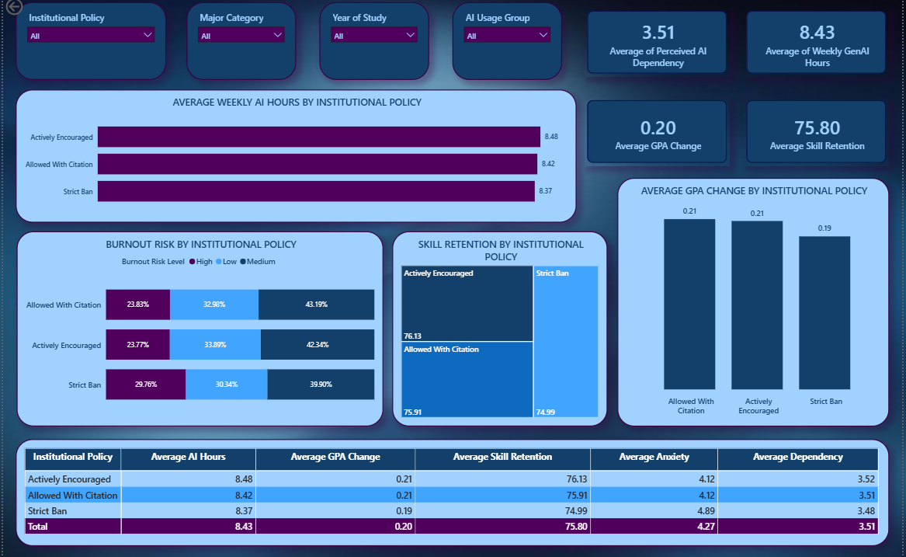
The Institutional Insights page investigates the relationship between institutional AI policies and student outcomes using a Clustered bar chart, 100% Stacked bar chart, Clustered column chart, Treemap, KPI cards and a Matrix. The page compares AI usage, GPA improvement, burnout risk, and skill retention across different institutional policy groups.
Key Insights
- AI-supportive institutional policies were associated with slightly higher GPA improvement.
- Skill retention remained relatively consistent across different policy groups.
- Students studying under AI-supportive policies generally reported lower burnout levels.
- Differences between policy groups were smaller than the differences observed across AI usage groups.

CONCLUSION
This mini project analysed a dataset of 50,000 student records to examine the impact of Generative Artificial Intelligence (GenAI) on students' academic performance, study habits, and overall wellbeing. Using Microsoft Excel and Microsoft Power BI, the data was cleaned, transformed, and visualised to identify patterns and relationships between AI usage and student outcomes.
The analysis indicates that AI can positively support academic performance when used in a balanced and purposeful manner. Students with moderate AI usage consistently achieved higher average GPA improvement and better skill retention than those with either low or high levels of AI usage. This suggests that responsible AI use may enhance learning, whereas excessive reliance does not necessarily lead to improved academic outcomes.
The findings also highlight the importance of prompt engineering skills. Students with advanced prompt engineering skills demonstrated stronger academic performance and higher skill retention, indicating that effective use of AI tools is more beneficial than simply increasing the amount of AI usage.
From a wellbeing perspective, higher AI usage was associated with increased AI dependency, higher burnout risk, and greater exam anxiety. Although these findings represent associations rather than cause-and-effect relationships, they suggest that excessive dependence on AI may have negative implications for students' learning behaviours and wellbeing.
The analysis of institutional policies showed relatively small differences between policy groups. However, students studying under AI-supportive policies generally demonstrated slightly better academic outcomes and lower burnout levels than those under stricter policies, suggesting that responsible AI integration may be more beneficial than complete restriction.
Overall, this project demonstrates how data analytics and business intelligence tools can transform raw educational data into meaningful insights. The dashboards developed in Microsoft Excel and Microsoft Power BI provide an effective way to explore the impact of AI on students and support informed decision-making for students, educators, and educational institutions.

